# **Development of a Vein Locating and Detecting Machine using Image Analysis**

## Clients

Mapua University, Self Made Project for thesis

## Objective / Goals / Purpose

To create a vein detecting and locating device that would help medical practitioners in locating subcutaneous veins in the arm using various Light Emitting Diodes. A Light Dependent Resistor is used to detect the reflected light from the vein and is processed by a Raspberry Pi to alert the user if a vein is present in the area.

## Technologies Used

Raspberry Pi, C++, Python, Bluetooth, Arduino

## Description

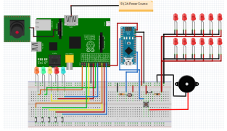

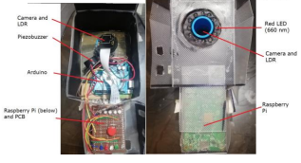

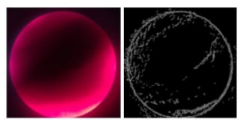

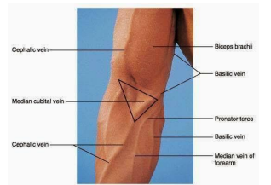

This project uses an Arduino and a Raspberry Pi, the former to process the voltage to the electronic components while the latter to perform image processing on the device. The user places the machine in the region of the patient’s arm where a vein might be located, then the light reflected from the skin is captured by the LDR. Light intensity is then converted to variable resistance by the LDR. Once the threshold is exceeded, then a piezo buzzer is activated indicating that a vein may possibly exist in the area. The Raspberry Pi takes a picture of the detected area and performs image processing techniques to the picture using various image processing techniques to further highlight areas in the picture which may contain the vain. This is then sent to the smartphone of the user via Bluetooth.